DELIVERABLE 1
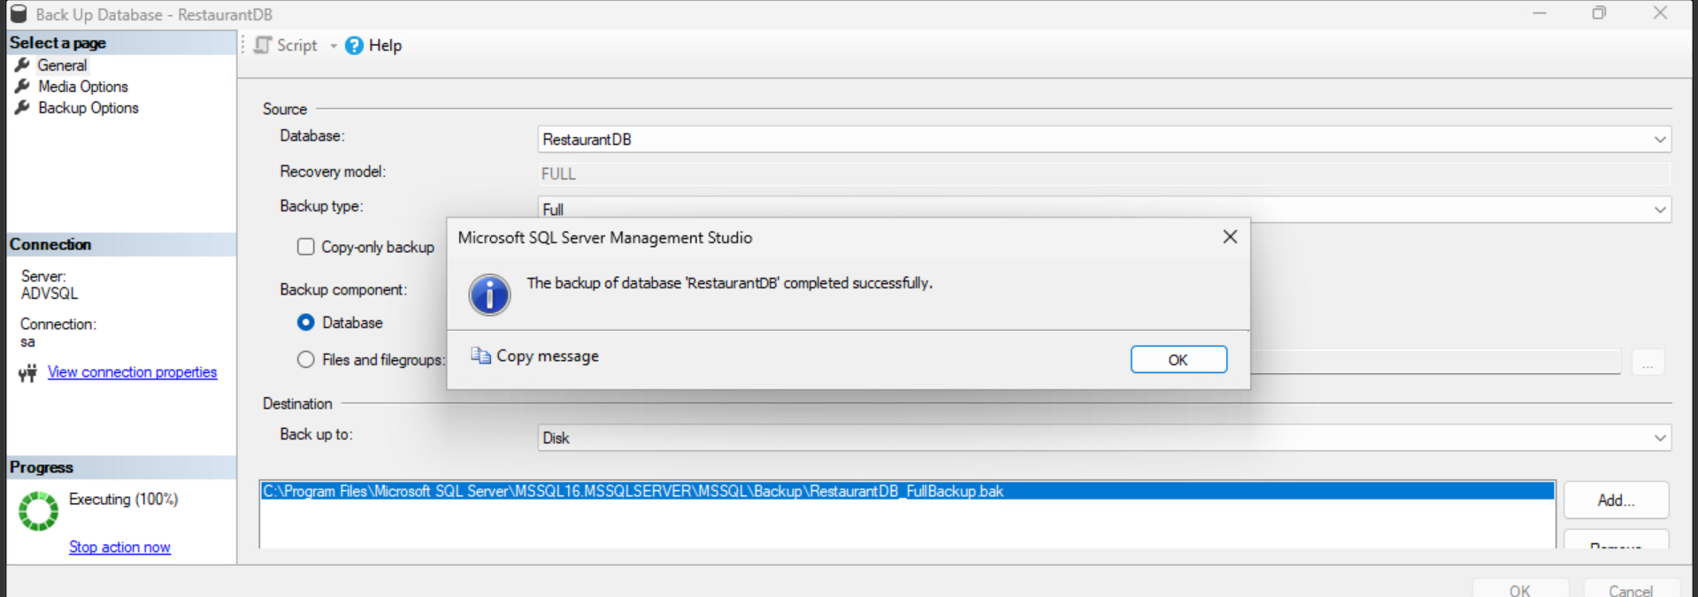Backup completed screenshot
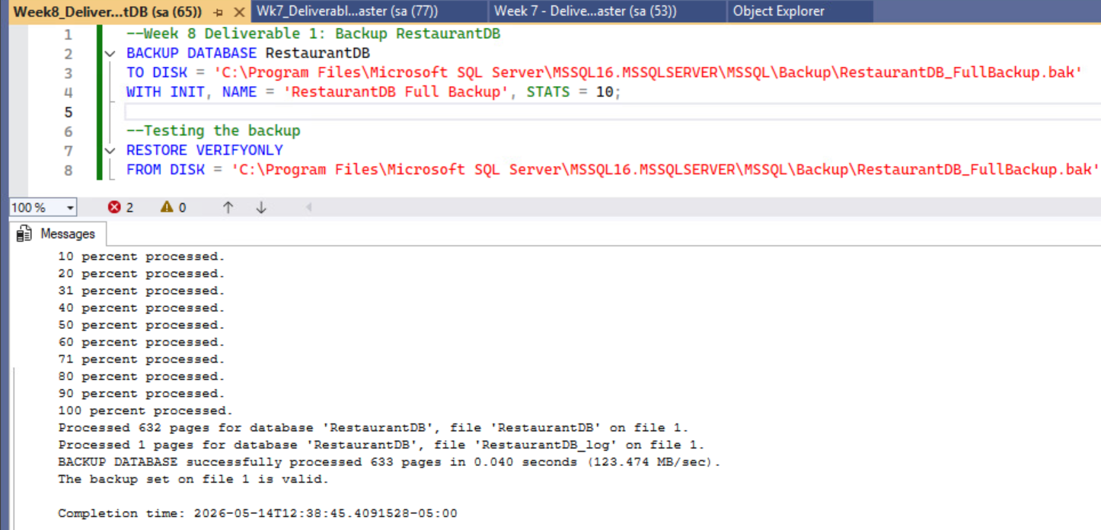
Backup SQL file code and execution screenshot

DELIVERABLE 2
Log File Creation Code
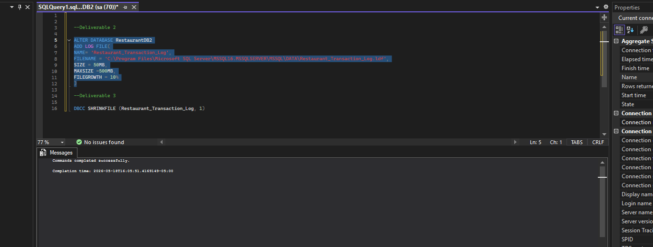

DELIVERABLE 3
Log File Before Truncation (50MB)
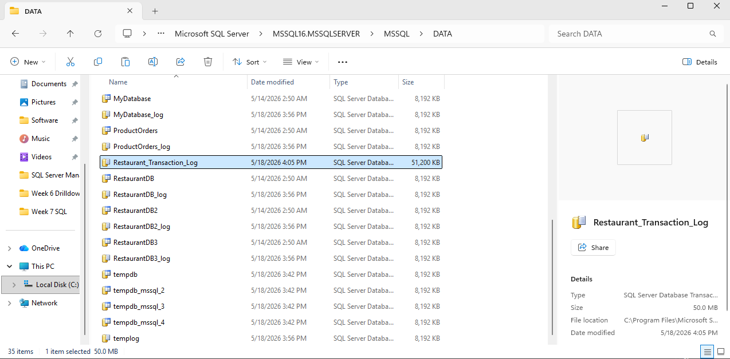

Log File Truncation Code
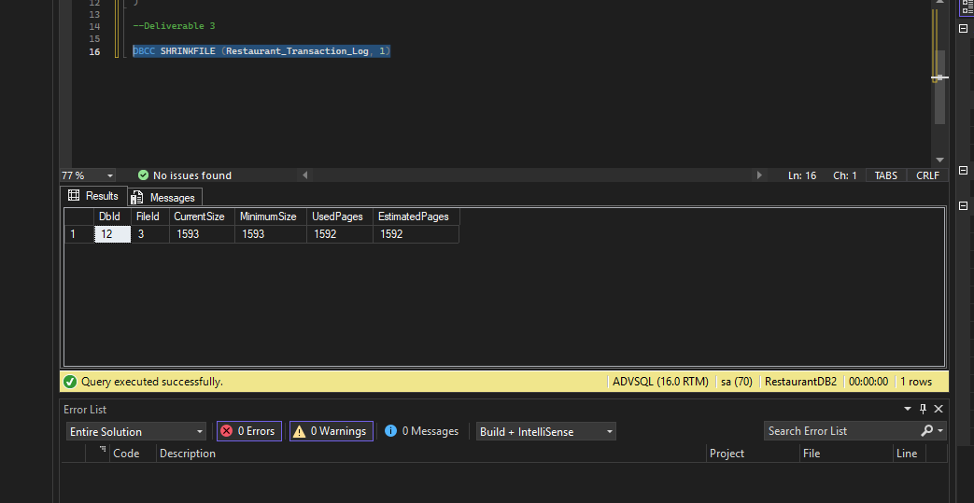

Log File After Truncation (12.4 MB)
